**Project Description**

**Introduction:**

The project is based on an application for a Tennis Club.

Users:

* Management
* Players

**Players:**

Players can save\view their scores. They can book matches, update their details and pay their fees.

**Management:**

The management can add/remove players. They can check if a player has paid the fees or not.

**Code:**

The coding is done by using structs. There are Player, Score, and Tennis type structs that are used in the project.

**The Presentation Layer:**

The presentation layer is the CMD.

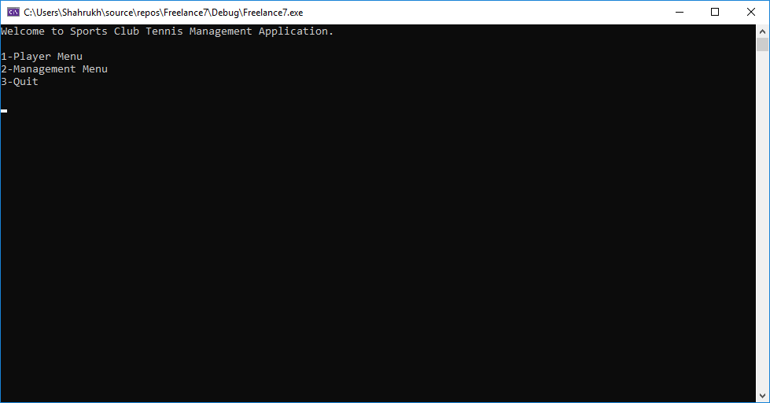

**Implementation layer:**

All the files have been separated according to their functionalities. Header and code files have also been kept separated.

**Storage Layer:**

ASCII Files have been used for the storage of data. There are two files in the system “Data.txt” and “Scores.txt”

**Run:**

The program is fairly simple to run. Just follow the instructions as shown in the command prompt. Enter the numbers shown with each option to navigate through them.